**Flow of Organization Category Wise Claim registration module screen display**

1. **Creation of Organization** : User will create organization for below mention organization category
   1. Bus
   2. Train
   3. Taxi
   4. Private Cars
   5. Private Bus
   6. Rented Vehicles

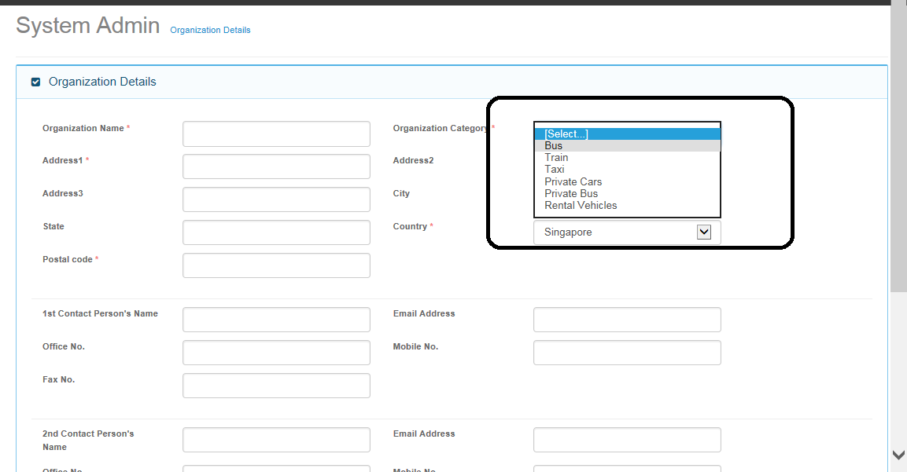

1. **Assigning Organization to User:** 
   1. On User Admin module, created organization will be assigned to user.
   2. On User Details Tab Screen, First user will choose country and then list of organization which is created under selected country will be displayed on organization access tab screen in user admin module. ( Not Yet implemented , Can we add drop down list on user details screen for country , which will have values from Country master ?)

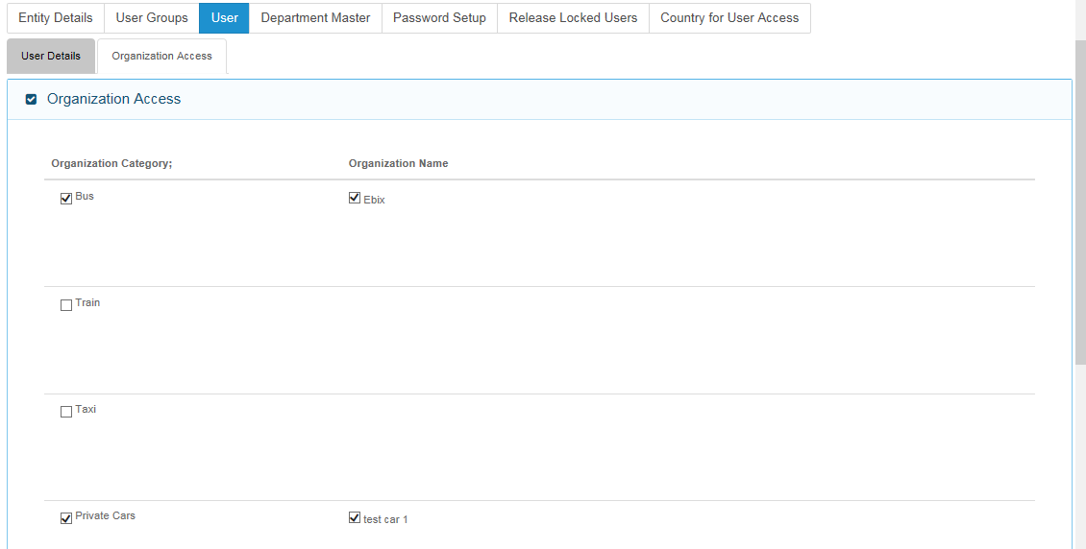

Dexter – 03 Feb 2015:

Yes, this is a good suggestion.

Varun Kumar Gupta – 3 February 2015

Ok

1. **New Claim registration Module :**
   1. On Accident screen, List of Organization will be displayed which is assigned to logged in user.
   2. Based on Select Organization’s Category, all other screens will be displayed. ( Asai needs to provide details of all screen’s fields changes based on organization category)

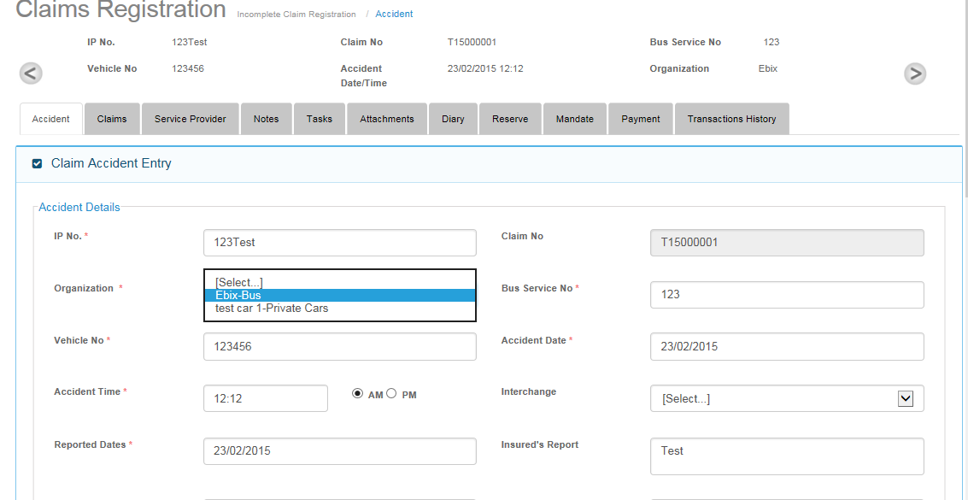

Dexter – 03 Feb 2015:

1. Please kindly confirm that this screen will only be made available on the New Claims Registration.

This is because the flow is that any manual claims creation (or known as Unreported Claims) will only be done on New Claim Registration Section. After user has saved, this manual claim will flow to the Incomplete Claims Registrations if the user did not click on Complete Button.

Uploaded Claims from SAP and TAC will be presented in the Incomplete Claims Registration.

2. How will the user link Manual Claims (or known as Unreported Claims) to Reported Claims?

Varun Kumar Gupta – 3 February 2015

* What link do we need to create between manual claim and reported claims?
* Please discuss this point in meeting.

Dexter – 4 February 2015

The Link is to convert an UnReported Claim into a Reported Claim.

Flow Is:

1. User creates UnReported Claim because they have information about the Claim but the Accident Team (TAC) has not provided them with the Actual Claim Information (i.e. Reported Claim).
2. User will input some of the information they know in the System and wait for the TAC Team to upload the Claims
3. If TAC have uploaded (usually indicated by the same accident vehicle and accident date) to the System, the user will need to convert the UnReported Claim into a Reported Claim. Information from the Reported Claim will overwrite the UnReported. Fields that are not populated by the TAC Claim will automatically be brought over.
4. Therefore we will need to provide this LINK in the system to convert UnReported Claim into Reported Claim.
5. Also note that an UnReported Claim may not have a Reported Claim so this type of Claim is just for users to review purposes.

3. As mentioned in the Project Status File and also during conference call that Aasai will no longer be providing the screen fields for the rest of the organization categories.

Please refer to Pte Car Draft Sample Screens 11-11-14.pdf for the screen fields needed for the rest of the organization. Your team can proceed to implement the screen fields as well.

Also note that Taxi will have 80% similarities and we are waiting for CDGI to come back to us with the screens marked out for changes.

Varun Kumar Gupta – 3 February 2015

* Till Date we were waiting to get excel file for all claim registration module screens from asai.
* Asai has also discussed one excel named as “CDGI-FieldsLayout”, on meeting held on 27th nov 2014.
* Please give confirmation of PDF file, as this file is created based on old UI of claim registration module and now we are following “UI” of “Claim registration Module Screens” Presentation file.
* Do we over write changes done so far for bus category and implement format as mentioned in PDF file.
* Please go through document and discuss in meeting.

Dexter – 4 February 2015

* It was understood in the last few meetings that there will be no more updating on the Excel File for all Claim Registration Module Screens from Aasai. You or Pravesh may want to call him to clarify on this.
* We can also confirm as of today that there’s no more of such Excel File for all Claim Registration Module Screens.
* This PDF File is not to replace any current screens created for Bus and Train Organizations. This PDF File is meant for creating screens for the rest of the Organization Categories (e.g. Private Bus, Commercial Vehicle, Rental Vehicles). The Screens for Taxi is 80% similar to the PDF File.
* It is only the Flow from the Bus and Train that is to be applied for the rest of the Organizations.
* The screens from the PDF File is meant for refreshing the system when user chooses the Organization belonging to other organizations other than Bus and Train.